Technical Stack & Architecture Document
Project: Skating Sports Federation of India (SSFI) Platform
Version: 1.0
Date: January 25, 2026

1. Executive Summary
The platform will be a high-performance, SEO-optimized web application built on the MERN/PERN Stack (MySQL/Postgres, Express, React, Node). It is designed to host 3D interactive elements without compromising load speeds, using server-side image processing to minimize bandwidth usage on Hostinger infrastructure.

2. Frontend (The User Interface)
Goal: Lightweight, SEO-First, and Visually Immersive.
Component | Technology | Reasoning
Core Framework | Next.js (React) | Critical for SEO. Unlike standard React, Next.js renders pages on the server (SSR), making them instantly readable by Google bots. It also optimizes performance automatically.
Language | TypeScript | Ensures type safety across the application, preventing bugs in the complex registration forms.
Styling Engine | Tailwind CSS | Ultra-lightweight utility-first CSS. It generates the smallest possible CSS file size (removing unused styles), ensuring fast load times.
3D Engine | React Three Fiber (R3F) | A React renderer for Three.js. It allows us to load the 3D Hero Section elements efficiently without blocking the main thread.
Animation | Framer Motion | For smooth, physics-based transitions (e.g., sliding cards, modal popups) that don't jitter.
State Management | Zustand | A lighter alternative to Redux for managing complex states (like the Multi-step Event Registration Wizard).

3. Backend (The Logic Core)
Goal: Secure, Scalable, and capable of heavy media processing.
Component | Technology | Reasoning
Runtime | Node.js | Non-blocking I/O, perfect for handling concurrent registrations during peak windows.
API Framework | Express.js | The industry standard for Node. Lightweight and flexible for building the REST APIs defined in our schema.
Image Engine | Sharp | (Crucial) An insecure/high-speed image processor. When a user uploads a 5MB JPEG, Sharp will auto-resize it and convert it to WebP format (e.g., 50KB) before saving to disk.
File Handling | Multer | Middleware to handle multipart/form-data for Aadhaar and Photo uploads.
Validation | Zod | For strict validation of user inputs (e.g., ensuring Aadhaar is a valid string, dates are correct) before they hit the database.

4. Database & Storage
Goal: Compatibility with schema.sql and Hostinger.
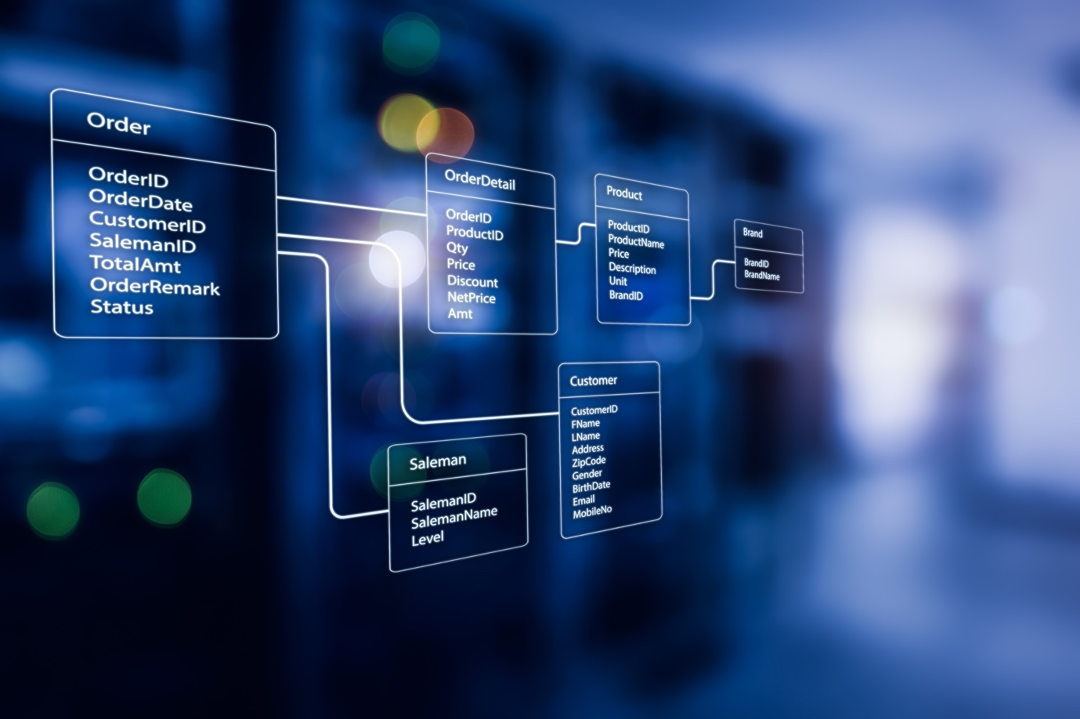
Shutterstock
Explore
Component | Technology | Reasoning
Database | MySQL (v8.0+) | Chosen for native compatibility with Hostinger's standard SQL hosting environment. It supports the relational structure needed for the hierarchy (State -> District -> Club).
ORM | Prisma | A modern bridge between TypeScript and SQL. It will auto-generate the type definitions from your existing schema.sql and handle migrations safely.
File Storage | Local / Hostinger Filesystem | Initially: Stored in a secured /uploads directory on the Hostinger server.  Scalability Option: Can switch to AWS S3 later if storage exceeds Hostinger limits.

5. Infrastructure & Deployment (Hostinger)
Goal: Cost-effective and stable.
Component | Technology | Reasoning
Hosting Type | Hostinger VPS (KVM) | Recommended. Shared hosting often restricts Node.js processes and custom libraries like Sharp. A VPS gives us full root access to install the necessary image processing tools.
Process Manager | PM2 | Keeps the Node.js backend alive 24/7. If the app crashes, PM2 automatically restarts it.
Web Server | Nginx | Acts as a "Reverse Proxy." It sits in front of the Node app, serving static files (images, CSS) instantly and compressing data (Gzip/Brotli) for speed.
SSL | Let's Encrypt | Free, auto-renewing SSL certificates provided via Hostinger/Certbot.

6. The "Auto-WebP" Workflow
To ensure the site remains lightweight despite heavy user uploads:
- Upload: User uploads avatar.png (2MB).
- Intercept: Backend (Multer) receives the file in memory buffer.
- Process: Sharp takes the buffer:
  - Resizes to max-width (e.g., 800px).
  - Compresses quality to 80%.
  - Converts format to .webp.
- Save: System saves avatar.webp (45KB) to the disk.
- Database: Updates the user record with the path /uploads/avatar.webp.

7. SEO Strategy (Technical Implementation)
- SSR (Server Side Rendering): The "Events" and "News" pages will be pre-rendered on the server so Google sees the full content immediately, not a loading spinner.
- Dynamic Metadata: The <head> tags (Title, Description, OG Image) will be dynamically generated based on the specific Event or News article being viewed.
- Sitemap.xml: Auto-generated script to list all active event pages for Google indexing.

